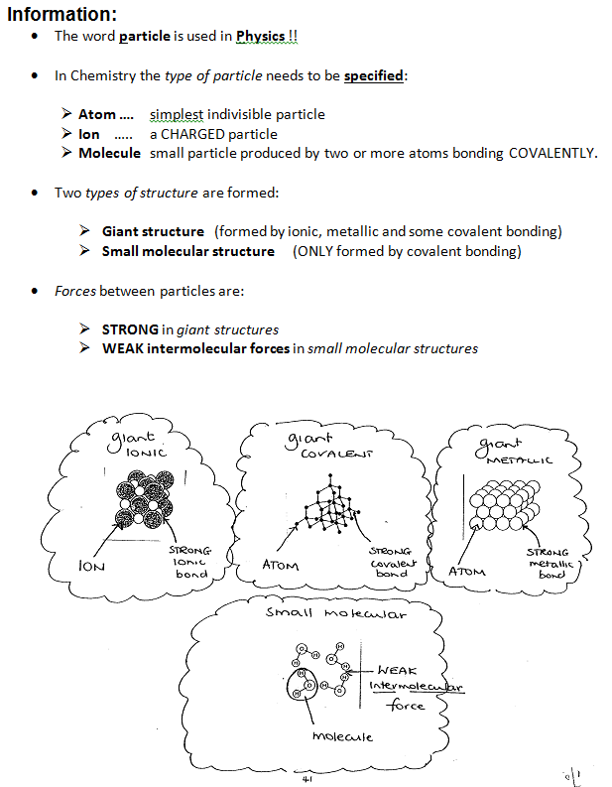
The Language of Structure and Bonding

Questions:
- Use the key words when answering these questions.
- All questions are worth 3 marks (therefore require 3 clearly expressed points)

- Explain why sodium chloride has a high melting point

- Explain why water has a low melting point

- Explain why diamond has a high melting point

- Explain why aluminium has a high melting point

- Explain why carbon dioxide is a gas at room temperature

Key words:
atom, ion, molecule, giant structure, molecular structure,
bond, intermolecular force, energy, strong, weak

